CBS In-Flight Script
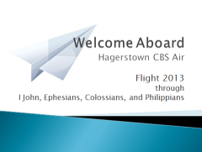
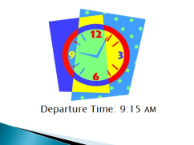
Flight Instructions given by announcer; stewardesses dressed in dark blazers with matching scarves; skirt; indicates when slide should be displayed
Welcome aboard __(Name of class)___ CBS Air Flight 20__ (year) through (Name of Study/studies for the year). Our Captain will be the Maker of the friendly skies, with __(name of TD)__ (stand briefly or wave) serving as our co-pilot. We thank you for arriving on time today and every Thursday out of respect for others. We look forward to gathering together at 9:15 a.m. for the opening each week in the __(Location)__. As our on-time departure rate is 99%, we encourage you to arrive early at the gate for boarding, especially if you are travelling with small children.

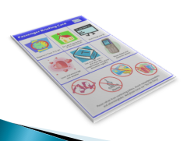
We direct your attention to the attendants in the front of the aircraft; they will now demonstrate our in-class procedures which will help you follow our CBS guidelines cheerfully. You can also find a copy of these instructions (flight attendants hold up Passenger Briefing Card) in your flight information folder.

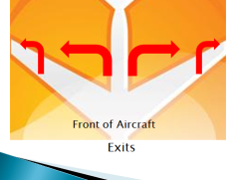
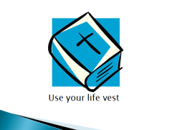
This aircraft is equipped with several emergency exits (point them out using two fingers-center doors, then sides); please take a few moments now to locate your nearest exit. In some cases, your nearest exit may be behind you. Our doors are not equipped with an inflatable slide as we will not be traveling over water today. However, please note the location of your life vest (hold up Bible); to use the vest, simply open to the portion of Scripture being studied, pray, and begin reading. If you do not have a life vest of your own, please see the Co-Pilot or one of our core leader crew (core leaders pop up and down) who will be happy to issue one for your use.

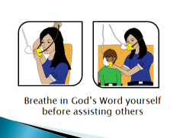
(Demonstrate oxygen mask) In the event of a sudden increase in life’s pressures, or if you are traveling with small children or others who need assistance on their journey through God’s Word, we advise that you put your own oxygen mask on first, and breathe deeply of God’s Word in prayer and study, and then proceed with assisting those in your care.
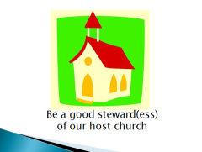
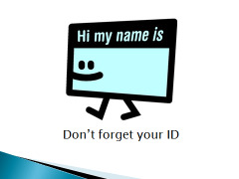
The co-pilot has turned on the Nametag sign. If you haven’t already done so, please take your seat and put on your nametag (attendant puts on nametag). And please make sure your seat back is in the full upright position; as guests in this church, we want to be good stewards of the host church’s facilities.

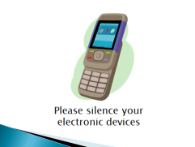
(Hold up cell phone and then lower) At this time, we request that all mobile phones, pagers, radios, and remote controlled toys be silenced for the full duration of the morning, as these items might interfere with the Holy Spirit’s navigational and communication equipment.
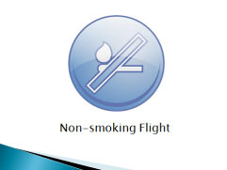
We remind you that this is a non-smoking flight. Smoking is prohibited in the entire aircraft, including the lavatories.
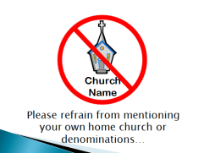
Other items which should be avoided as they may result in smoke or even flames during discussion time include mentioning your home church, specific denominations, books, television or radio program titles,

and politics.
We also ask that you refrain from advertising or sales during this and future flights with CBS Air.
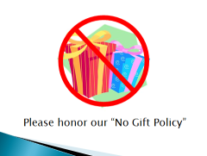
For the enjoyment of your fellow travelers, we suggest that you take time to reach out and encourage others in the class, to be loving when you do not see eye-to-eye, and even willing to go the extra frequent flyer mile for one another. Please honor our no-gift policy; however, creativity with cards (hold up Thank You card) and other acts of kindness are certainly encouraged.
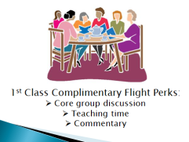
If you have questions about your lesson (hold up lesson book) or need assistance, please don’t hesitate to ask your core leader (core leaders pop up and down) or one of our Servants Team attendants; they are here to make your journey more enjoyable. To get the most out of your flight, we suggest you complete your lesson questions each week and hide God’s Word (hold up Bible) in your heart. Should you be unable to finish your lesson due to turbulence in your weekly schedule, please be sure to catch the next class and enjoy feasting on our complimentary core group discussion (even if you can’t actively participate), along with the teaching time and lesson commentary.

For your enjoyment and comfort, we ask that, if possible, you remain in class until after the teaching time is completed; our expected arrival time is 11:15 a.m. Once the co-pilot has parked at the gate and turned off the microphone, please check around your seat for any personal belongings, coffee cups, or water bottles, you may have brought onboard with you; if you’re going to leave anything behind, please ensure it is something we’d like to have! If you have borrowed any magazines or hymn books (hold up hymn book) during your time with us, we would appreciate your returning those to the back of the room. And please be sure to proceed promptly to the classroom baggage claim area to collect your children.

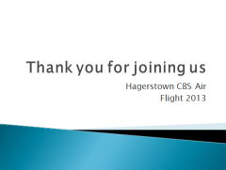
On behalf of __(class name)__ CBS Air and the entire leadership crew, we’d like to thank you for joining us on our flight through __(Name of Study)__. We look forward to seeing you on board again next Thursday. And have a pleasant day!

Materials for flight attendant presentation:
- Passenger Briefing Card (poster size for stewardesses)
- Bible
- Oxygen mask (or small plastic container with elastic bands, balloon attached)
- Name tag
- cell phone
- lesson book and Bible again
- hymn book
- Thank you cards

